

Egyptian Green Building Council: Formation & Achievements

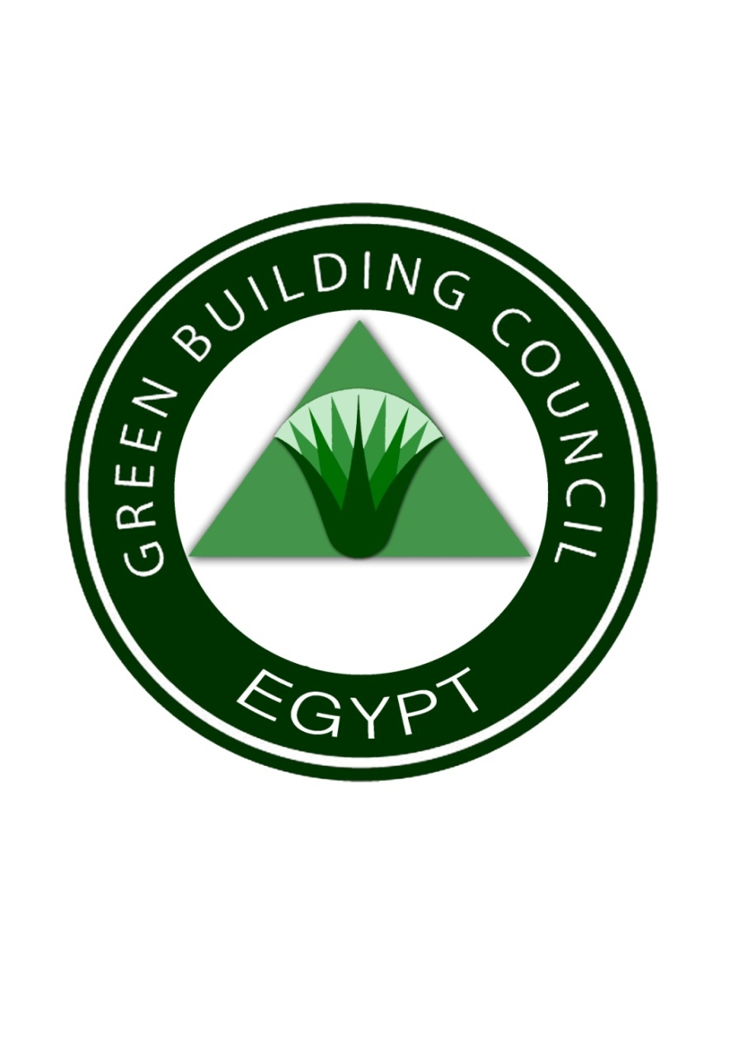

For the past two decades, the Egyptian government has worked feverishly to improve building energy efficiency and address green house gas emissions. The motivation for this effort has been the realization that population momentum would ultimately place enormous demands on all sectors of the Egyptian state and that these demands would have the potential to dramatically limit long term growth of the Egyptian economy. At the time, detailed studies had shown the close link between population growth and energy. For that reason, Egyptian stakeholders and government officials have looked for methods to reduce power consumption and GHG emissions. In that sense, developing energy efficiency building codes was a critical the first step in that process and identifying alternative paths towards energy efficiency has been a second.

Within the building sector, efforts at enforcement have been nonexistent. Proposals to improve performance in this area have been put forward but interest and manpower have been lacking. While many people are examining this dilemma others are searching for alternative systems to address the same issues and increase awareness regarding their importance. The following paragraphs highlight significant new initiatives that will ultimately bridge the gap between code design and code compliance.

1. *Establishment of Egyptian Green Building Council:* In January 2009, a major step was taken by establishing the Egyptian Green Building Council (EGBC). Membership in the EGBC consists of both national and international personalities including government ministers from Cabinet level agencies, officers from respected NGOs, prominent businessmen, seasoned labor leaders, and major contractors. One of the objectives for establishing this council is to provide a mechanism to encourage building investors to adopt BEECs as well as other sections of existing codes that satisfy both energy efficiency and environmental conservation. By focusing on new construction, the EGBC could use its leverage as a professional organization to educate and convince engineers, builders, contractors and owners about the benefits of green construction to the individual, to the community, to the nation and most significantly to the bottom line. In this manner, green construction would be the desired goal for all new building projects and building energy efficiency codes would be the materials, tools and road map to achieve the desired goal. In that sense, the primary motivation was to eliminate any stigma or clichéd perspectives associated with green construction and, instead, present green construction as a financially logical and appropriate course of action that integrates important global and national concerns to produce viable sustainable products that meet the short term and long term needs of people.

As an immediate action to activate the role of this council was the approval of developing a national Green Building Rating System called the *Green Pyramid Rating System (GPRS)*, the council has commissioned to define the framework of a rating system and a national committee has been formed to review and ultimately approve the Green Pyramid Rating System, which is expected to be completed and in place by the end of 2009 or the first quarter of 2010. Recognizing the unique ecological, industrial and social challenges of the region, the rating system will help to define what constitutes an “*Egyptian Green Building*”. To accomplish that goal, the rating system will build upon the Egyptian BEECs and integrate proven methodologies and techniques used in successful programs from the United States, Europe, Asia, South America and the Middle East.

The *Green Pyramid Rating System* represents the EGBC’s effort to improve occupant well-being, environmental performance and economic returns of buildings using established and innovative practices, standards and technologies. The Rating System, like its forbearers in other nations, will identify basic intent, requirements and documentation submittals that are necessary to achieve each prerequisite and voluntary credit in support of new and existing projects that ultimately seek to qualify for certification and gain access to potential benefits.

The initial response by the Construction Industry to establishing a Green Building Rating System and awarding Green Permits was overwhelmingly positive for several reasons including the development of logical and valuable incentive system that would encourage compliance and reward efficiency. The incentives related to a Green Permit included:

1. *Access to preferred and prime locations and property per the Government of Egypt,*
2. *Tax Breaks, Waivers and Postponements,*
3. *Financial Assistance including guarantees, credit and insurance,*
4. *Utility Concessions,*
5. *Equipment support and finance, and*
6. *Employee support and assistance.*
7. *The Eco-villages National Project:* As a second achievement for the EGBC, a proposal for building the first Eco-Village in Egypt was approved by the Minister of Housing, Utilities and Urban Communities. The Eco-Village will be constructed according to Green Principles, Green Building Regulations and the existing BEECs. Currently a site South of Cairo has been selected. The design and planning of the structure has been assigned to the HBRC. The motivation for Eco-Village is the understanding that Egypt faces a critical situation with its homeless population and that sustainable standards of living for this community may be beyond the scope of the current free market-driven economic system in Egypt. At the same time, the increasing homeless population will have a direct effect on the economy, security and social solidarity of the nation. In that sense, the goal of the Eco-Villages national project is to provide a platform for sustainable technologies, systems, methodologies and techniques that will be used to develop safe communities where homeless citizens can regain their place in the Egyptian society, make positive contributions to their lives and indirectly improve the welfare of the nation. Within this sustainable model, the proposed Eco-village is expected to deliver to its community members guaranteed health care, basic education, religious guidance, effective social assimilation, work training, and skill development, In return the community will produce food, energy, and the output of numerous cooperative enterprises. As a bonus, the participants experience the responsibility of property ownership and the benefits of self-sufficient communities and self-reliant individuals. The Venn diagram of Figure (1) attempts to integrate ownership with production and consumption, where the intersection represents all that is used to sustain the local development.



**Figure (1):** Sustainable Triad for Eco-Village

A proposed initial development calls for the utilization of 5,000 hectares of rural-urban space to establish a sustainable “perma-culture” that is founded on an agro-industrial base. In this way, the eco-village will be founded on an agricultural-industrial engine that will integrate human activity with natural surroundings to produce market quality foods, goods and products, while maintaining a sustainable standard of living.

1. *National Affordable Non-Conventional Housing Project:* In 2008, a major pilot project was entrusted to the HBRC to explore the possibility of introducing an energy efficient, environmentally friendly Housing System for low income families. The same group who initiated the GUPC was selected to lead the project. This group assured the council that BEEC would be integrated into the design and development of the New Housing Project, which would use energy efficient materials and support. As such, a primary criterion for the selection of a New System has been compliance with BEEC and the rating system under development.

Since the “new system” will be the backbone of numerous proposed large scale public developments, it will be relied upon to satisfy strict energy, social and aesthetic requirements. For this reason, it will act as a driver for private, government and individual construction. Not surprisingly, numerous product manufacturers have stepped forward to herald their products and numerous developers have stepped forward to define their visions of communities that utilize these systems. As a result, the exercise is bringing together architects, urban planners, engineers and manufacturers to forge a green vision that maximizes LEED certifications, satisfies building efficiencies requirements and lays the foundation for sustainable communities. Current examples include proposals for low income housing in 6th of October City as seen in Figures (2) through (4). All of these projects seek to provide quality low and middle income housing within large sustainable and fully integrated communities that optimize efficiency, comfort and volume. The final developments will create an integrated community that includes hospitals, clinics, stores, malls, cinemas, clubs, mosques and schools.

 

**Figure (2):** Low Income Housing **Figure (3):** Optimized Communities



**Figure (4):** Competition for Green Systems and Developments associated with the National Affordable Non Conventional Housing Project

1. *ICC HBRC Building Inspector Program:* In 2004, a memorandum of understanding was been signed between the Ministry of Housing Utilities and Urban Communities (MHUUC) with both the *International Code Council* of the USA *(ICC)* and the International Accreditation Service (IAS) to develop a national program to train licensed Special Technical Inspectors. The new program, modeled after ICC's training and certification programs in the U.S., begins with initial certification levels for structural concrete, fire protection, plumbing and mechanical inspection. This new collaboration will be coordinated with additional research and technical support from HBRC, with a goal if bringing technological innovation and insight from the laboratory to the job site.

The demand for new green housing in Egypt is enormous, while the availability of competent technical professionals is limited. For this reason, new general inspectors will be in great demand and will have a major role in enforcing BEECs and other established building codes as well as supporting the Green Building Rating System. More significantly, the certification process will add competent professionals to the workforce; give individuals the opportunity to distinguish themselves and stand out in a particular field; and improve the general knowledge and awareness of green principles in the building community. A newly certified inspector will be on the frontlines in the battle for compliance, enforcement and energy efficiency in Egypt. He or she will have increased earning and career advancement potential and will be entrusted with protecting public health, safety and welfare.

The significance of the last statement should not be dismissed. Properly trained Inspectors should place the public's welfare above all other interests; demonstrate integrity, honesty and fairness in all transactions; recognize the continuing need for developing improved safety; maintain professional competence in all areas of employment; accept no personal favors for public services rendered and conscientiously avoid all circumstances that could compromise professional integrity. If these ideals are maintained then the foundation for a Green Egypt will have been secured.

*v) Development of the World Bank (WB) Report on Implementation of Building Energy Efficiency Code in Egypt:* A comprehensive WB report is being developed that provide in-depth information on different aspects of building energy codes and environmental issues related to the building industry in Egypt.

vi) Publicity and Outreach: The following efforts were performed by the EGBC to spread the word on the council and to raise the awareness for green building approach:

* *Two conferences and workshops were developed; the first one was held in Cairo in January 2009 under the sponsorship of EGBC, HBRC and the University of California, Irvine. The conference was followed by one day LEED seminar that was attended by more than 100 professionals and developers. The second conference was held also in Cairo in March 2009 under the sponsorship of EGBC, HBRC , US National Science Foundation, US AID office in Cairo and University of Alabama. The conference was attended by both the Minster of Housing, Utilities and Urban Communities and the Minster of Environment along with many government official and high profiles engineers architects, contractors and media. An American Society of Civil Engineers Conference is planned to be held in June 2010 focusing in affordable housing and Sustainable Construction. Another International Conference on Non-conventional Green materials will be held in Cairo under the sponsorship of EGBC in September 2010. In December 2010, the first Arab League Conference on Sustainable construction will be held with the participation of several Ministers of Housing from different Arab Countries.*
* *Numerous articles were written in the prime national newspapers and popular magazines as well as professional newsletter to provide information on the green building approach and encourage stakeholders to join the council.*
* *Several TV interviews were conducted to provide information to the general public on the green building movement in Egypt and worldwide,*
* *A trip to several countries by several members of the EGBC was completed including India, China, Indonesia and Emirates to visit several green building sites and meet with Green Building officers. The trip also include visits to several manufacturing plants to green building products and encourage these manufacturers to enter the Egyptian market through direct sale of initiating local plants.*

**Why Green Pyramid?**

Giza Pyramids are considered to be some of the oldest green structures in the world (refer to Figure 5) for several reasons including:

* *Sustainable Structural System (optimized geometry for High-Rise structure),*
* *Green Construction and use of Natural Green Materials,*
* *Natural Ventilation System,*
* *Natural Lighting System,*
* *Durability with Minimum Maintenance, and*
* *Harmony with Surrounding Environment.*

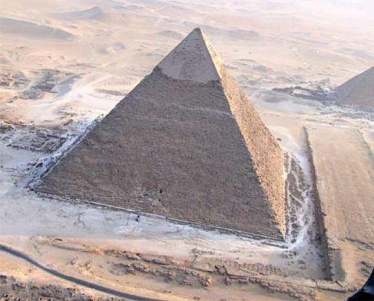

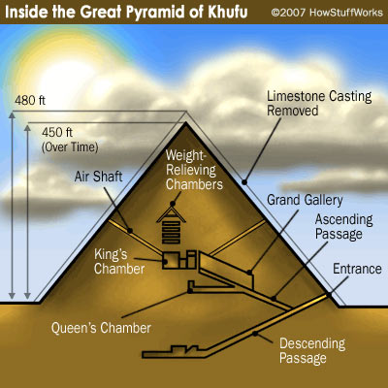

**Figure (5):** Giza Pyramid: *A Green Building Concept*

**The Green Pyramid Rating System (GPRS) Levels:** There are three levels for green buildings certification according on the Egyptian GPRS:

1. *Silver Pyramid,*
2. *Golden Pyramid, and*
3. *Green Pyramid.*

Unlike other international rating systems, the highest level of certification is labeled “Green” rather than platinum, for example, to raise the awareness and confirm that ultimate goal and promote the fact that the most valuable level is reaching “*green*”.

**Future Events:**

* *The EGBC website is now under construction and will appear soon*
* *The EGBC is working on Filing a Membership Application to the World Green Building Council b y the end of 2009 or start of 2010.*

**Address & Contact Information:**

* **Egypt Headquarter:**

*Mostafa Eldemirdash, Ph.D., EGBC Vice Chair and HBRC Chair*

The Green Building Council of Egypt

Housing & Building Research Center (HBRC)

87 Tahrir St. Dokki - Giza

P.O.Box.1770 Cairo

Postal Code 12311

Egypt

* **USA Contact:**

*Ayman S. Mosallam, Ph.D., P.E., EGBC Founding Member*

Professor, Civil & Environmental Engineering Department  
University of California, Irvine (UCI)  
Irvine, California 92697-2175, USA  
Phone: Office: 949-824-3369  
         Cell: 714-767-4564  
          e-mail: mosallam@uci.edu  
          Web Page: http://www.eng.uci.edu/users/ayman-mosallam

